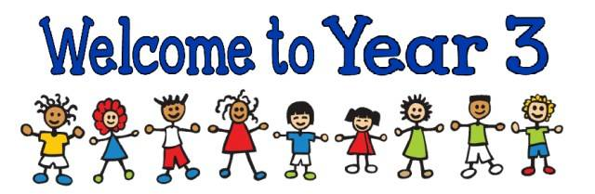
Dear Parents and Carers

It was an absolute pleasure to welcome your children into Year three this week. They have started the term full of enthusiasm and I am looking forward to the year ahead with them all.

Our first theme in Year 3 is ‘Proud to be me!’. We will be looking at what makes us important, unique, special and understanding different feelings. Here is an overview of what we are going to cover during this theme.
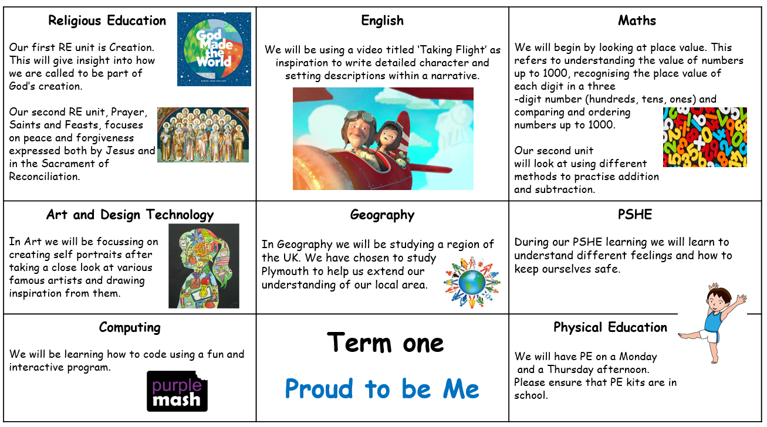

Our second theme is ‘Festivities’. We will be taking a look at all the different and wonderful festivities held across the world ending with the build up to Christmas. Here is a quick overview about what we will cover in our second theme.
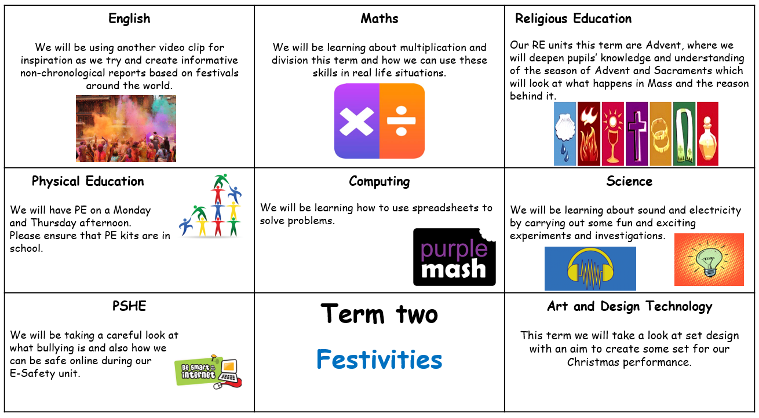

EARLY MORNING TASKS The morning routine allows the children to come into the classroom from 8.45
onwards. Upon arrival they settle quickly to learning tasks such as number operation practice and word games.
Children must arrive by 8.55 to start the school day on time. Thank you for your support with this so far.

HOME READING Your child will continue to bring home a reading book. Please listen to your child read and,
more importantly, talk about what is being read as often as you can. Sharing a story together is a great way to
spend time with your child.

HOME LEARNING This includes reading on a daily basis. Homework always relates to learning in class. The
children will be asked either to practise applying knowledge and skills already introduced in class or to complete
a research project linked to the term’s theme. The children will also be expected to practise number facts (e.g.
times tables) and spellings as set. Homework is set every Friday and is due in the following Wednesday.
Spellings are set every Friday and tested the following Wednesday.

SCHOOL UNIFORM: The children have arrived back at school after the summer holiday looking smart and ready to learn. Please refer to the following details from our prospectus if you are unsure:

UNIFORM:
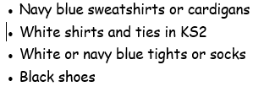
● Grey trousers/shorts
● Navy blue skirt or pinafore
● Blue summer dresses

JEWELLERY MAKEUP:
● For safety reasons, children should not wear jewellery to school. Children with pierced ears may
wear discreet studs, although these must be removed for PE and swimming.
● No nail varnish/makeup

PE:
● All pupils should have a PE bag to hold their sports kit, comprising of their house colour t-shirt, navy
blue shorts and plimsolls or trainers.
● Trainers may be needed for outside PE throughout the year.
● During the winter, children may have tracksuit bottoms in their bag and a jumper with long sleeves.
Please ensure that all kit and uniform is clearly named so that your child can easily locate lost items of clothing.

SNACKS AND PACKED LUNCHES: We are committed to being a healthy school so please supply your child with a healthy snack for breaktime (no crisps or chocolate I’m afraid). All children require
water bottles for use in class. These must have a sports cap so that school books are not at risk of being
damaged.

Please do not hesitate to contact me with any queries or concerns. I am always happy to speak to you when you
pick your child up at the end of the day or contact me via email on amudford@stpaulsplymouth.com . If you
require more time, I am more than happy to make an appointment with you.

Kind regards

Mr Mudford

