Dear Parents and Children of Year 2,

Welcome to the autumn term of Year 2. I am very much looking forward to seeing you all and working with you this year. I know that we have recently been through a very unusual and challenging time in education. Many of the children haven’t been in school since March and I am aware that there will be many anxieties on return to school about how different things may be however, we, the staff, are ready to welcome you and your children back to school with excitement and support. Please feel that you can contact myself via email, amudford@stpaulsplymouth.com, or on ClassDojo if you have any questions and I will be happy to get back to you.
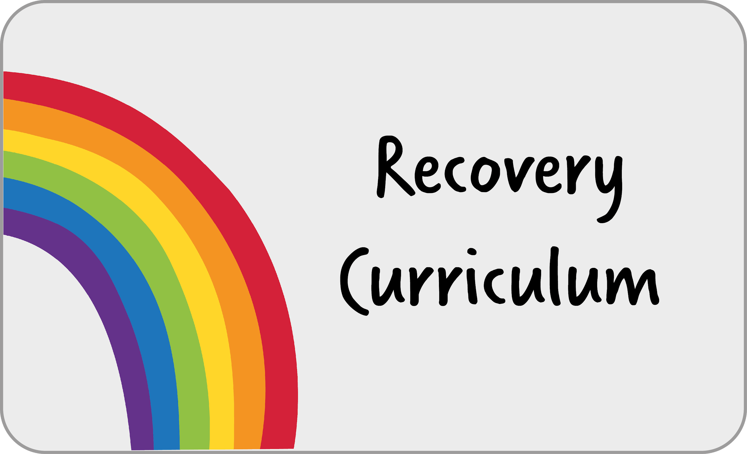
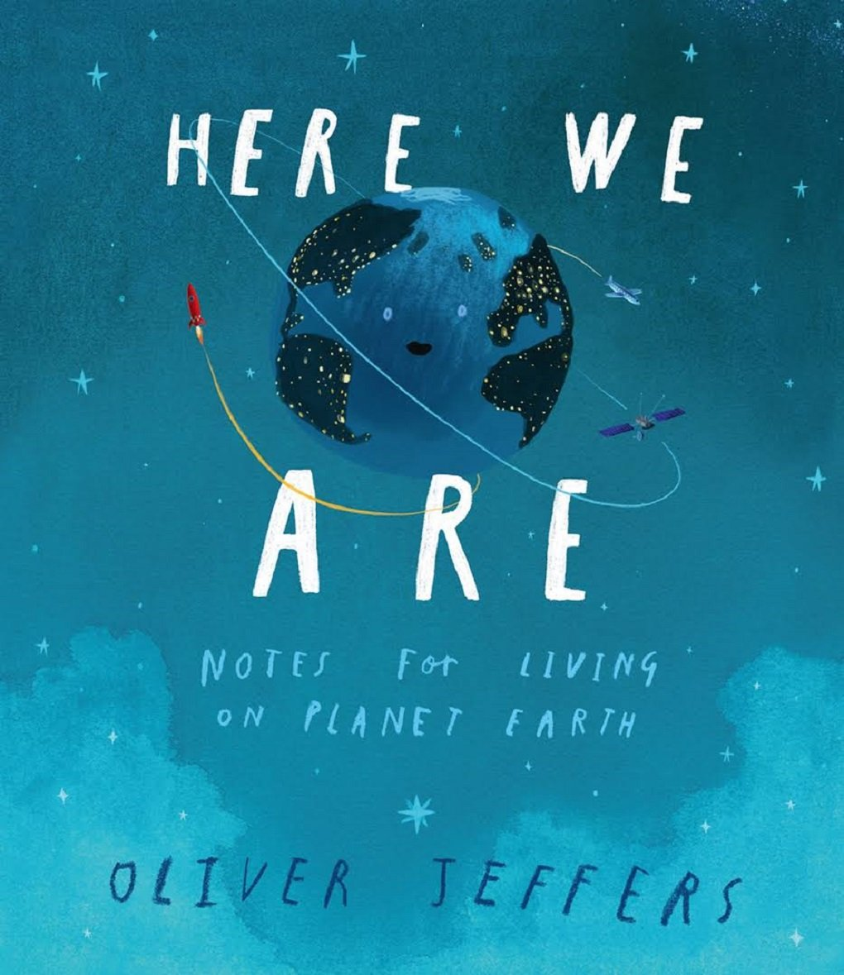
Following this challenging time, we have planned a recovery curriculum to support your child’s transition back to school. We’ve put together a series of lessons focused on community recovery to help us to bring our school back together. We’ve split these resources into five themes (self-efficacy, hope, gratitude, connectedness and worries), with each drawing upon some of the factors that underpin wellbeing and positive psychology.

Across the school, we are using ‘Here We Are’ by Oliver Jeffers as our English transition unit. This will provide your child with the opportunity to reconnect with each other and re-engage with school life using their creativity in English and art.

_______________________________________________________________________________________________

I’m very excited to share with you that we are beginning a new journey in regards to the teaching of the curriculum.
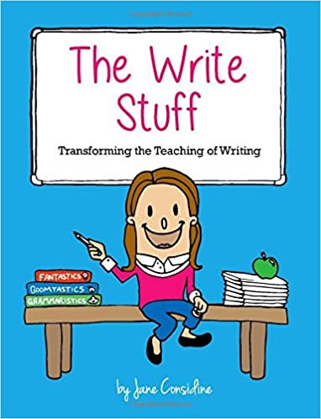
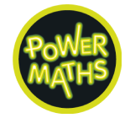
We are going to be following ‘The Write Stuff’ for our English learning. Jane Considine has developed an approach that enables children to develop as confident writers through teacher modelling. I’m really looking forward to using this new approach to support your child in becoming accomplished writers.

We are also going to be following ‘Power Maths’ for our maths learning. This is a mastery programme designed to spark curiosity and excitement and nurture confidence in maths. This is a fantastic curriculum that I am sure the children will enjoy using to develop their maths knowledge, understanding and skills.

We are also going to be following ‘Come and See’ for our RE learning. This is a programme designed to allow children to search for meaning in life through a Christian perspective. It provides children with the opportunity to explore, reveal and respond throughout the learning process.

As part of the Plymouth Catholic School Cluster (the six Catholic schools in Plymouth), we have worked together to create a progressive curriculum for the foundation subjects that seeks to provide pupils with the essential knowledge they need to be educated citizens in tomorrow’s world.

Autumn Term 1
Religious Education  Our first RE unit, Family, we learn all about God’s love for us.  Our second RE unit focuses on the sacrament of Baptism and the signs and symbols attached to it. | English  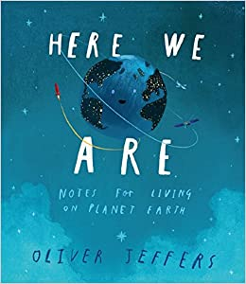  We begin the year looking at the book ‘Here we are.’ We will write captions, poems and postcards! | 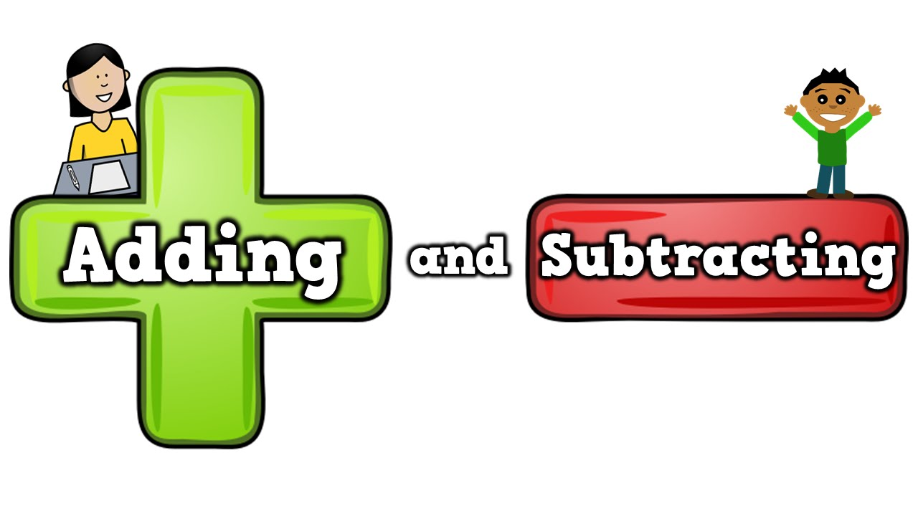  Maths  This term our maths will focus on developing our understanding of place value. We will then continue to develop our addition and subtraction skills.
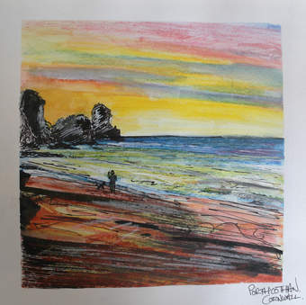  Art and Design  We will study the work of a local artist and create a range of sea inspired pieces. | 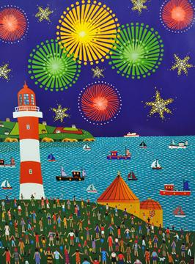 | Music  We will compose music inspired by our amazing city and its features.
Computing  We will be learning how to log on and begin to learn about coding. As in previous years, we will cover online safety. | PSHE  We will be thinking about what it means to belong to a group and the roles and responsibilities that come with it. | 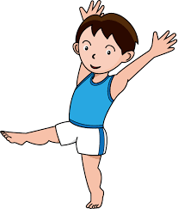  Physical Education  Our PE sessions will be led by an outside coach who will teach us lots of new skills.
Autumn Term 2

Religious Education  Our RE units this term will focus on Advent and take a look at the books used in church. | English  In our English sessions we will be delivered using ‘The Write Stuff’ approach. We will collect examples of exciting vocabulary and then try to use it in our own writing. | Maths  We will begin to develop our knowledge of multiplication and division. Then we shall increase our understanding of fractions.
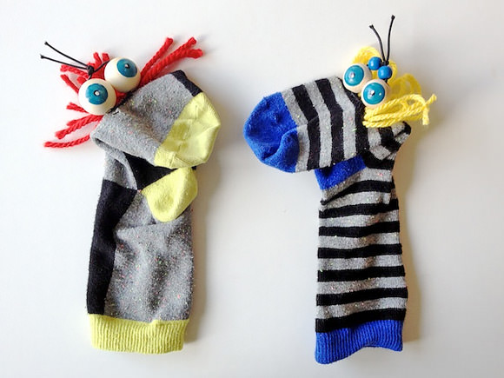  Design technology  In our DT sessions we will design and make our own puppets. | 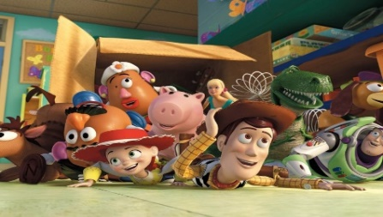 | History  Our studies this term will focus on toys and how they have evolved.
Computing  This term we will learn how to working with text and images, saving and editing, use a search engine. | PSHE  This term we will continue to look at friendships and how we can develop positive relationships. | Science  In our science lessons we will be learning about animals, including humans and what they need to survive.

HOME READING We will be changing books each Monday and Thursday, when your child will be given two books. Your child will be expected to reread these books. Rereading books is good practice as it moves children from reading for decoding, through reading with expression and finally onto reading for meaning. Please listen to your child read and, more importantly, talk about what is being read as often as you can.

HOME LEARNING Home learning always relates to learning in class. The children will be asked either to practise applying knowledge and skills already introduced in class or to complete a research project linked to the term’s theme. The children will also be expected to practise number facts (e.g. number bonds to ten) and spellings as set. Home learning is set every Friday and is due in the following Wednesday.

SCHOOL UNIFORM: The children have arrived back at school after the Summer holiday looking smart and ready to learn. Please refer to the following details from our prospectus if you are unsure:
- Grey trousers/shorts
- Navy blue skirt or pinafore
- Navy blue sweatshirts or cardigans
- White polo shirts in Reception/KS1
- White or navy blue tights or socks
- Black shoes

Jewellery/makeup:
- For safety reasons, children should not wear jewellery to school. Children with pierced ears may wear discreet studs, although these must be removed for PE and swimming.
- No nail varnish/makeup

PE:
- For PE, children should wear a white t-shirt and navy blue shorts. In colder weather, navy blue leggings or joggers may be worn.
- This term our PE lesson is on Thursday.
- Children should come to school dressed in their PE kit.

Snacks and packed lunches We are committed to being a healthy school. All Foundation stage and KS1 children are provided with fresh fruit on a daily basis and do not require any additional snacks. All children require water bottles for use in class. These must have a sports cap so that school books are not at risk of being damaged. Only water is allowed to be consumed in class time.

Please ensure that your child brings a coat with them each day or some suitable form of outerwear.

Please do not hesitate to contact me with any queries or concerns. I am always happy to speak to you when you pick your child up at the end of the day or contact me via email on amudford@stpaulsplymouth.com . If you require more time, I am more than happy to make an appointment with you.

Kind regards,

Mr Mudford

