Year 3 Home learning Autumn 1

Create a word wall using words that tell me all about you eg. Your name, age, family, hobbies, talents etc… | Write 10 sentences that describe you and how special you are. | Draw a self-portrait of yourself.
Talk to people in your family – what three things are most important to you? | 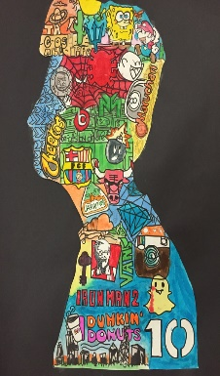  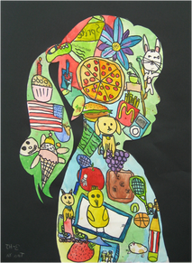 | When you grow up what do you want to be?  Write a paragraph explaining what and why.
Create a song about being proud of who you are. | Physical challenge: Create a dance routine to share with the class? | Bring in something from home that you are most proud of to share with the class.

Wk | English | Maths
1 | Make a list of the top ten things you like or like doing. | Spend 5 minutes each day practising your 5 times table.
2 | Write sentences/paragraphs to describe yourself.. | Spend 5 minutes each day practising your 10 times table.
3 | Write a review of a book you have read. Would you recommend it? Who to? | Spend 5 minutes each day practising your 2 times table.
4 | Create your own superhero and write a character description of them. | Spend 5 minutes each day practising your 3 times table.
5 | Tell me about someone who is important to you and why. | Spend 5 minutes each day practising your 4 times table.
6 | Write a story where you are the main character. | Spend 5 minutes each day practising counting in 2s, 3s, 4s, 5s and 10s.

Try to read every night too!

