Dear Parents and Children of Year 5

Welcome to the autumn term of Year 5. I hope you have all had a wonderful summer holiday and your child is ready to begin an exciting and challenging term.

Our first theme in Year 5 is ‘Plastic Fantastic?’. We will be looking at the impact that plastic has on our environment and discussing ways in which we can do our part to make changes. Here is a quick view of what we will cover in our first theme.
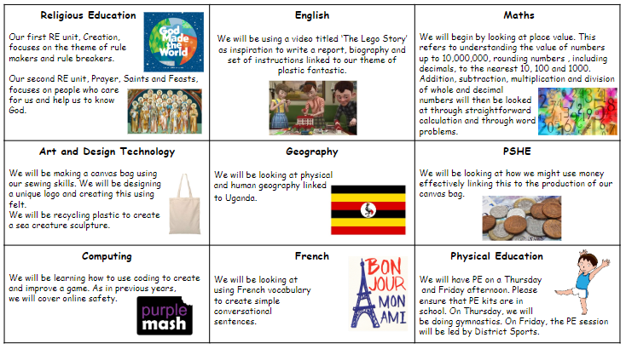
Our second theme is ‘Structures and Forces’. We will be looking at bridge structures specifically and using our design skills to put forces into action. Here is a quick view about what we will cover in our second theme.
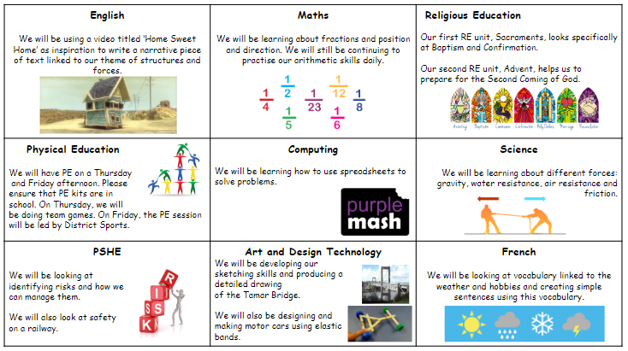

Home Learning – Your child will receive home learning linked to the learning that they have been completing in class. This will then embed any key skills they need to know. Home learning is due in on a Friday and will be returned to your child on the Monday. Please encourage your child to take pride in the presentation of their home learning by drawing straight lines using a ruler and pencil. Felt tips should not be used for writing.

Your child has a Times Table Rock Stars login. I encourage them to use this website as frequently as possible to practise their times tables. These are valuable facts that will support them with their mathematics learning in class.
Your child has a Purple Mash login. This website is fantastic for accessing interactive activities linked to the whole curriculum. They can practise their spellings, grammar skills, times tables and much more in a fun, exciting way, Please remember to use this resource. If you do not know your password then please feel free to ask.
School uniform: I am sure the children will arrive back at school after the summer holiday looking smart and ready to learn. Please refer to the following details from our prospectus:
Uniform:
- Grey trousers/shorts
- Navy blue skirt or pinafore
- Blue summer dresses
- Navy blue sweatshirts or cardigans
- White polo shirts in foundation/KS1
- White shirts and ties in KS2
- White or navy blue tights or socks
- Black shoes

Jewellery/makeup:

- For safety reasons, children should not wear jewellery to school. Children with pierced ears may wear discreet studs, although these must be removed for PE and swimming.
- No nail varnish/makeup

PE:

- All pupils should have a PE bag to hold their sports kit, comprising of their house colour t-shirt, navy blue shorts and plimsolls or trainers.
- Trainers may be needed for outside PE throughout the year.
- During the winter children may have tracksuit bottoms in their bag and a jumper with long sleeves.
Please ensure that all kit and uniform is clearly named so that your child can easily locate lost items of clothing.

Snacks and packed lunches: We are committed to being a healthy school. All Foundation stage and KS1 children are provided with fresh fruit on a daily basis and do not require any additional snacks. Children in KS2 (Years 3-6) need to bring a snack for morning break. Please support your child to develop good eating habits. Crisps or chocolate are not acceptable for morning snack.

All children require water bottles for use in class. These must have a sports cap so that school books are not at risk of being damaged. Only water is allowed to be consumed in class time.

Please ensure that your child brings a coat with them each day or some suitable form of outerwear.
I am sure we will have a great term; and I look forward to working in partnership with you and your child.

Mrs Griffiths and Mr Owen
Class teacher

