Dear Parents and Children of Year 3

Welcome to the autumn term of Year 3. Mrs Griffths, Mrs Smith, Mrs Eatwell and Mrs Mullett are looking forward to seeing you all and working with you this year. I know that we have recently been through a very unusual and challenging time in education. Many of the children in Year 3 haven’t been in school since March and I am aware that there will be many anxieties on return to school about how different things may be however, we, the staff, are ready to welcome you and your children back to school with excitement and support. Please feel that you can contact Mrs Griffiths or Mrs Mullett via email, smullett@stpulasplymouth.com, kmgriffiths@stpaulsplymouth.com or on ClassDojo if you have any questions and we will be happy to get back to you.
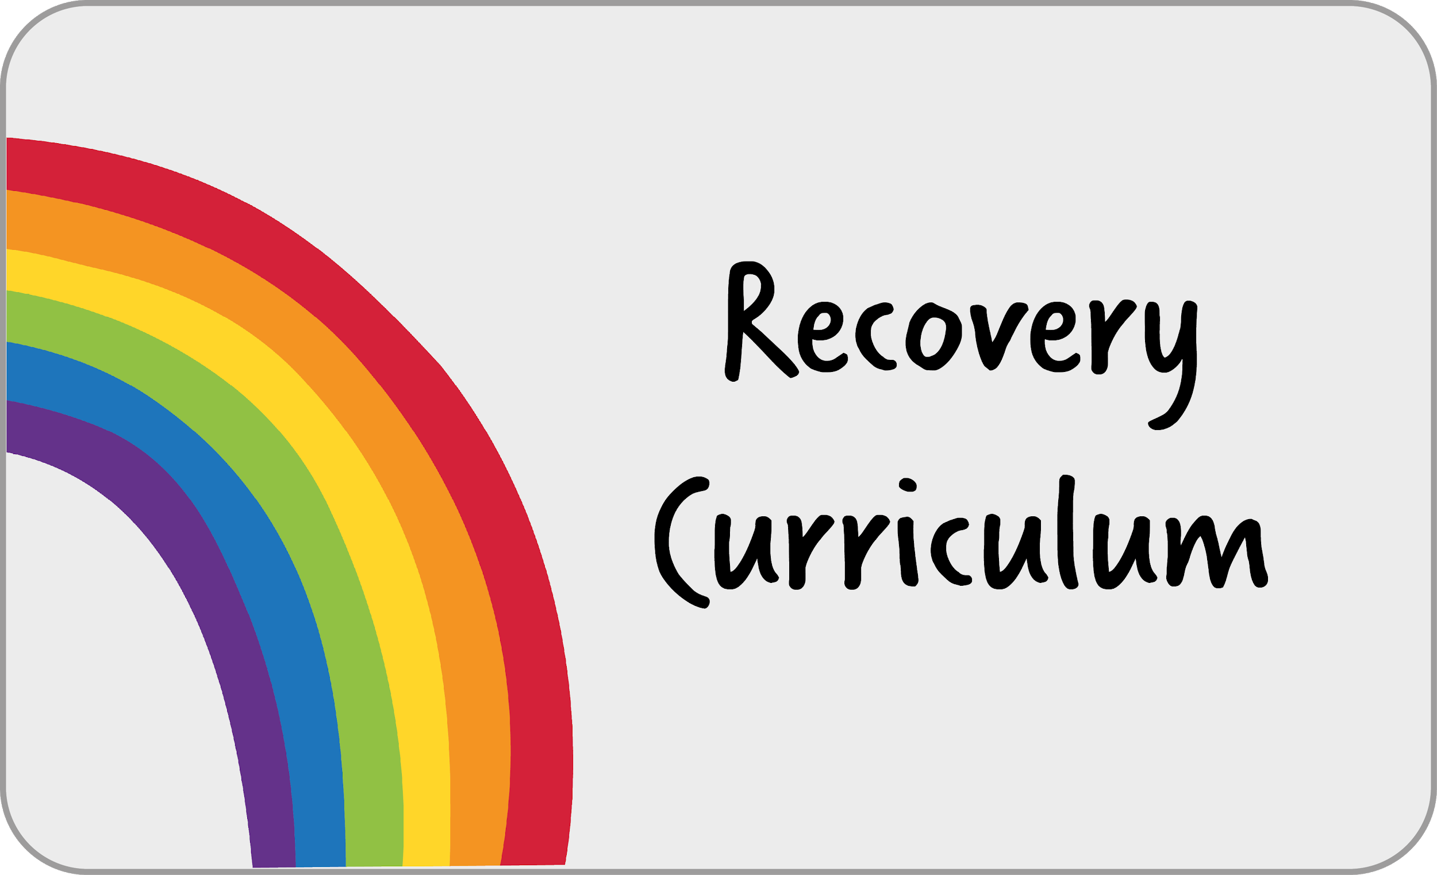
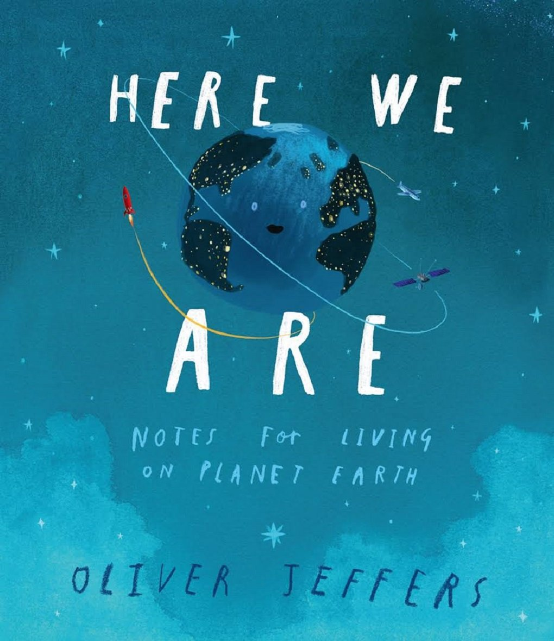
Following this challenging time, we have planned a recovery curriculum to support your child’s transition back to school. We’ve put together a series of lessons focused on community recovery to help us to bring our school back together. We’ve split these resources into five themes (self-efficacy, hope, gratitude, connectedness and worries), with each drawing upon some of the factors that underpin wellbeing and positive psychology.

Across the school, we are using ‘Here We Are’ by Oliver Jeffers as our English transition unit. This will provide your child with the opportunity to reconnect with each other and re-engage with school life using their creativity in English and art.

_______________________________________________________________________________________________

I’m very excited to share with you that we are beginning a new journey in regards to the teaching of the curriculum.
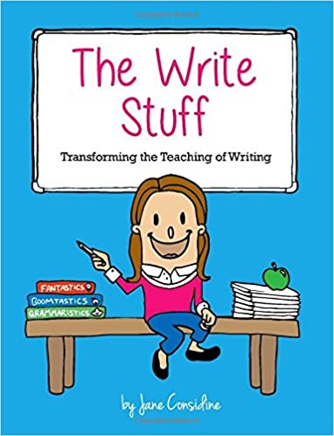
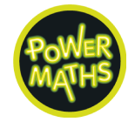
We are going to be following ‘The Write Stuff’ for our English learning. Jane Considine has developed an approach that enables children to develop as confident writers through teacher modelling. I’m really looking forward to using this new approach to support your child in becoming accomplished writers.

We are also going to be following ‘Power Maths’ for our maths learning. This is a mastery programme designed to spark curiosity and excitement and nurture confidence in maths. This is a fantastic curriculum that I am sure the children will enjoy using to develop their maths knowledge, understanding and skills.

We are also going to be following ‘Come and See’ for our RE learning. This is a programme designed to allow children to search for meaning in life through a Christian perspective. It provides children with the opportunity to explore, reveal and respond throughout the learning process.

As part of the Plymouth Catholic School Cluster (the six Catholic schools in Plymouth), we have worked together to create a progressive curriculum for the foundation subjects that seeks to provide pupils with the essential knowledge they need to be educated citizens in tomorrow’s world.

Autumn Term 1
Religious Education  Our first RE unit is about the Domestic Church (family) and how love is shown in a community linking to the fact that God shows unconditional love.  Our second unit is about our belonging and developing our knowledge around baptism, marriage, commitment and service. | 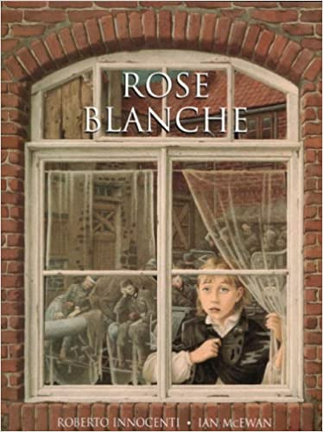  English  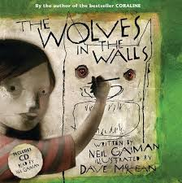  Our writing will be based on the book ‘The Wolves in the Walls’ which links to our PSHE topic of family  and belonging.  We will be writing a fictional piece of writing. Grammar will be interwoven into our English lessons to ensure that children are able to apply their knowledge and understanding to their writing. | Maths  We will begin by recapping our understanding of place value including comparing and ordering numbers up to 1000. We will then move on to look at rounding numbers to the nearest 10, 100 or 1000 and counting in multiples of 6,7,9, 25 and 1000.  In our second unit we will begin to look at addition and subtraction and being confident in using a formal method for both.
Geography  We will be learning about the rainforest this term, about the types of rainforests and how we can look after them. | Art  We will be learning about Henri Rousseau’s jungle tiger paintings and creating our own rainforest tribal masks. | Computing  We will be using search engines to find facts using keyword search.  We will also be learning how to navigate a website and how to stay safe online by going to appropriate websites.
Music  On Tuesday afternoon, Miss Matlock will be teaching music whilst Mrs Griffiths has her PPA time. | PSHE  We will be focusing on community in the first term and looking at what makes a community and our shared responsibilities. | Physical Education  On Tuesday afternoon, TGS coaching will be teaching PE whilst Mrs Griffiths has her PPA time.

Autumn Term 2
Religious Education  Our first two RE units are focused on the faiths Islam and Sikhism.  Our second unit is Advent where we prepare to receive Jesus into our lives and to share this gift with others at Christmas and throughout the year. | 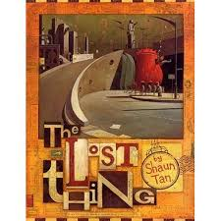  English  Our first writing unit will be based on the book ‘The Lost Thing’; this will produce a fictional piece of writing.  Our second unit will be based on report writing surrounding the topic of plastic pollution. Again, grammar will be interwoven into our English lessons. | Maths  We will begin by looking at multiplication and division using place value, known and derived facts to multiply and divide mentally. We will also be recalling our multiplication and division facts for multiplication tables up to 12.  Our second unit will look at perimeter, learning to convert between different units.
History  We will be learning about Roman Empire and its impact on Britain focussing on archeology/Infrastructure | Science  We will be looking at animals including humans. This will involve describing the function of the digestive system in humans, types of teeth and their functions and animal food chains. | Computing  We will be looking at coding including algorithms, testing and debugging. We will be writing an algorithm to show the Roman invasion of Britain.
Music  On Tuesday afternoon, Miss Matlock will be teaching music whilst Mrs Griffiths has her PPA time. | PSHE  We will be focusing on how to stay safe and on road safety. | Physical Education  On Tuesday afternoon, TGS coaching will be teaching PE whilst Mrs Griffiths has her PPA time

Home Learning: Your child will receive home learning linked to the learning that they have been completing in class. This will then embed any key skills they need to know. Home learning is due in on a Friday and will be returned to your child the following Monday. Please encourage your child to take pride in the presentation of their home learning by drawing straight lines using a ruler and pencil. Felt tips should not be used for writing.

Your child has a Times Table Rock Stars login. I encourage them to use this website as frequently as possible to practise their times tables. These are valuable facts that will support them with their mathematics learning in class.
School uniform: I am sure the children will arrive back at school after the summer holiday looking smart and ready to learn. Children will now be required to wear full uniform to school. It is not necessary to wash uniform every day but we do advise that children change out of their uniform immediately after arriving home and wash their hands with hot water and soap.
Please refer to the following details from our prospectus:
Uniform:
- Grey trousers/shorts
- Navy blue skirt or pinafore
- Blue summer dresses
- Navy blue sweatshirts or cardigans
- White polo shirts in foundation/KS1
- White shirts and ties in KS2
- White or navy blue tights or socks
- Black shoes

Jewellery/makeup:

- For safety reasons, children should not wear jewellery to school. Children with pierced ears may wear discreet studs, although these must be removed for PE and swimming.
- No nail varnish/makeup

PE: Children should wear PE kit to school on a Tuesday to remove the need to change. On colder days, it is acceptable for children to wear navy leggings or joggers instead of shorts. Trainers or plimsolls may be worn.

Snacks and packed lunches: We are committed to being a healthy school. All Foundation stage and KS1 children are provided with fresh fruit on a daily basis and do not require any additional snacks. Children in KS2 (Years 3-6) need to bring a snack for morning break. Please support your child to develop good eating habits. Crisps or chocolate are not acceptable for morning snack.

All children require water bottles for use in class. These must have a sports cap so that school books are not at risk of being damaged. Only water is allowed to be consumed in class time. School water bottles are available for purchase from the school office.

Please ensure that your child brings a coat with them each day or some suitable form of outerwear.
I am sure we will have a great term; and I look forward to working in partnership with you and your child.

Mrs Griffiths and Mrs Mullett
Class teachers

