St Paul’s Catholic Primary Long Term Plan Year Groups: 5/6 Academic Year: 2019-2020
Subject Area |  | Transition Unit | Autumn 1 | Autumn 2 | Spring 1 | Spring 2 | Summer 1 | Summer 2
Theme |  | Lost Words | Plastic Fantastic? | Structures and forces | Space | Marvellous Mayans | Plymouth | Olympics
Lead subject |  | PSHE | D and T/ Art | Science | Science | History and music/dance | History/ Geography | PE / Geography
Key text |  | Lost Words | On the Reef - Judith McMurray | Window - Jennie Baker | The Skies Above her Eyes - Charlotte Gullivan and Yuval Zommer | Rain player - David Wisniewiski | The Mayflower and the Pilgrims New World - Nathaneal Philbrick | Olympic Poems - Brian Moses and Roger Stevens
Hook |  |  | Junk modelling  Visit Delamore | Visit the Tamar bridge (boat ride under bridge and walk back)/ spaghetti towers | Visit the planetarium (i-DAT) or science dome | Chocolate making and tasting | Visit Hoe, Mayflower steps etc. | Plymouth olympian visit (whole school)
Outcome/Purpose for learning |  |  | Design and create a canvas bag to promote less plastic. | Design and make a bridge to support weight.  Design and make a balloon buggy. | Create a game about the solar system and planets. | Design and make a chocolate bar. | Create a piece of artwork in the style of Brian Pollard a local Plymouth artist. | Create a recipe for a healthy smoothie knowing the impact on a good lifestyle.  Make the smoothie.
English |  |  | The Lego story - reports, biography and instructions | Home Sweet Home - narrative and speech  Window | Pandora - non-chronological report | Ride of Passage - | The Lighthouse - narrative and report  The Mayflower - diary | Poetry
Maths | 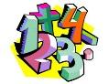 |  | White Rose Maths | White Rose Maths | White Rose Maths | White Rose Maths | White Rose Maths | White Rose Maths
RE | 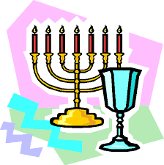 |  | God Matters | God Matters | God Matters | God Matters | God Matters | God Matters
PSHE/SMSC | 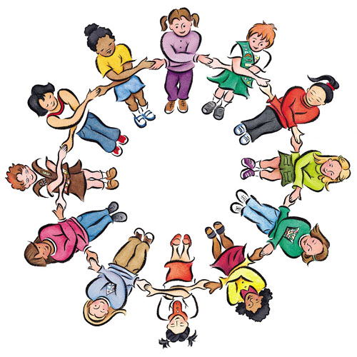 |  | How can money affect us? Link to bag design/cost etc | How can we manage risk?  Railway safety |  | What are human rights? | What makes a community?  What makes a happy and healthy relationship? | How can we stay healthy?
Science |  |  |  | Forces | Earth and Space |  |  | Animals including humans
Art and design | 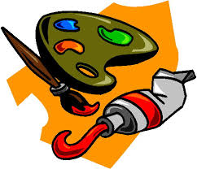 | Colour mixing/water colour/ various mediums etc. | 3D sculptures | Observational sketches of Tamar Bridge |  |  | Brian Pollard - artist study | Sketching figures Observational drawing - fruit
Computing |  |  | Purple Mash | Purple Mash | Purple Mash | Purple Mash | Purple Mash | Purple Mash
Design and technology | 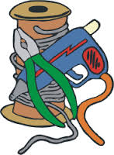 |  | Bag design | Bridge building Motor cars |  | Designing a chocolate bar |  | Fruit smoothies/kebabs
Geography |  |  | Uganda - physical and human geography |  |  | America - Place study | Plymouth - Local study (map, compass, coordinates etc) | Countries and location
History |  |  |  |  |  | Ancient Mayans | Mayflower
French yr5 | 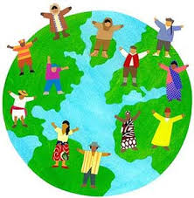 |  | I languages - year 3 | I languages - year 3 | I languages- year 3 | I languages - year 3 | I languages- year 3 | I languages- year 3
French yr6 |  |  | I languages- year 3 | I languages - year 3 | I languages - year 3 | I languages- year 3 | I languages- year 3 | I languages- year 3
Music |  |  | Ocean sounds |  |  | Rain/storm music using percussion |  | Opening ceremony  music
PE | 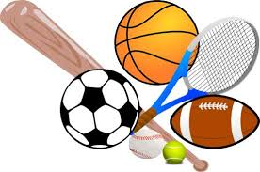 |  | District Sports | District Sports | District Sports | District Sports | District Sports | District Sports

