Year 1 Curriculum Newsletter - Autumn 2019 6th September 2019
Dear Parents and carers,
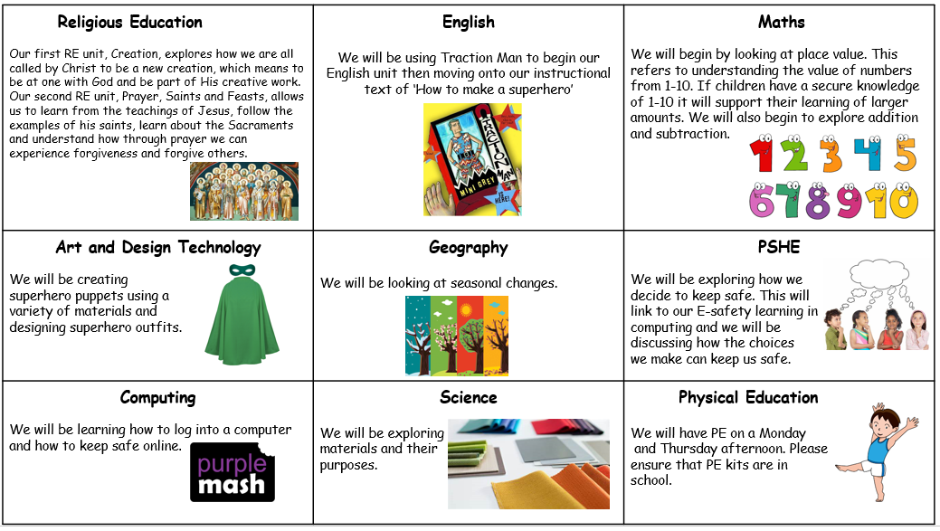
It was a pleasure to welcome your children into Year one this week, they have settled well and I have enjoyed hearing all about their summer holidays. I am delighted to be continuing this next step in their school journey with them. Our first theme will be ‘Incredible Me!’ We will be exploring personal qualities of ourselves and others and thinking about real life superheroes.

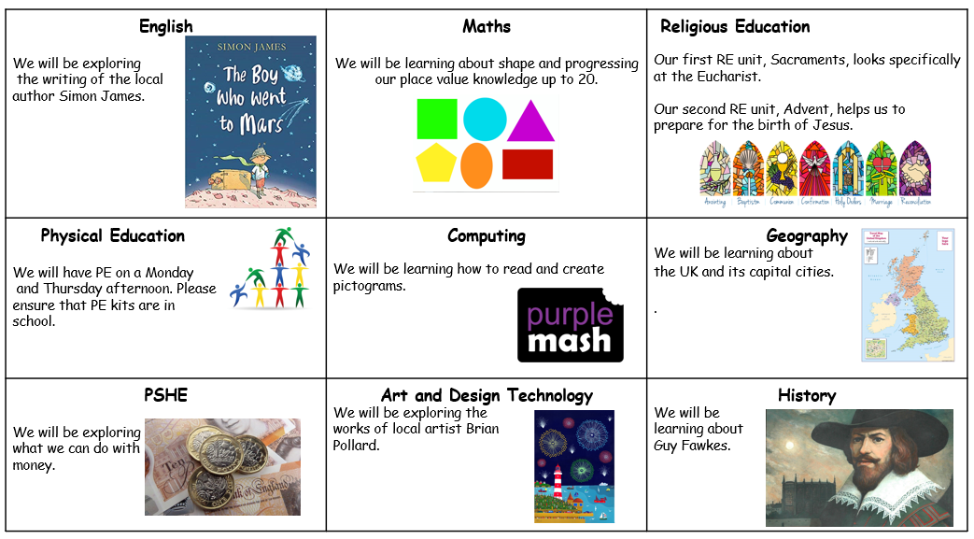
Our next theme will be ‘Plymouth on a Postcard’ where we shall be exploring our local area.

EARLY MORNING TASKS The new morning routine allows the children to come into the classroom from 8.45 onwards. Upon arrival they settle quickly to learning tasks such as number operation practice and word games. Children must arrive by 8.55 to start the school day on time. Thank you for your support with this so far.
HOME READING Your child will continue to bring home a reading book. Please listen to your child read and, more importantly, talk about what is being read as often as you can. Sharing a story together is a great way to spend time with your child.
HOME LEARNING This includes reading on a daily basis. Homework always relates to learning in class. The children will be asked either to practise applying knowledge and skills already introduced in class or to complete a research project linked to the term’s theme. The children will also be expected to practise number facts (e.g. number bonds) and spellings as set. Homework is set every Friday and is due in the following Wednesday. Spellings are set every Monday and tested every Friday.
School uniform: The children have arrived back at school after the Summer holiday looking smart and ready to learn. Please refer to the following details from our prospectus if you are unsure:
Uniform:
- Grey trousers/shorts
- Navy blue skirt or pinafore
- Blue summer dresses
- Navy blue sweatshirts or cardigans
- White polo shirts in foundation/KS1
- White shirts and ties in KS2
- White or navy blue tights or socks
- Black shoes

Jewellery/makeup:
- For safety reasons, children should not wear jewellery to school. Children with pierced ears may wear discreet studs, although these must be removed for PE and swimming.
- No nail varnish/makeup
PE:
- All pupils should have a PE bag to hold their sports kit, comprising of their house colour t-shirt, navy blue shorts and plimsolls or trainers.
- Trainers may be needed for outside PE throughout the year.
- During the winter children may have tracksuit bottoms in their bag and a jumper with long sleeves.
Please ensure that all kit and uniform is clearly named so that your child can easily locate lost items of clothing.

Snacks and packed lunches We are committed to being a healthy school. All Foundation stage and KS1 children are provided with fresh fruit on a daily basis and do not require any additional snacks. All children require water bottles for use in class. These must have a sports cap so that school books are not at risk of being damaged. Only water is allowed to be consumed in class time, please use your new water bottles and return them daily. Afternoon snack is not part of the Year 1 timetable and will be gently phased out, it will completely stop at the end of this half term.

Please ensure that your child brings a coat with them each day or some suitable form of outerwear.
Please do not hesitate to contact me with any queries or concerns. I am always happy to speak to you when you pick your child up at the end of the day or contact me via email on sstrong@stpaulsplymouth.com . If you require more time, I am more than happy to make an appointment with you.
Kind regards,
Miss Strong

