Year 1 Home learning Autumn 2

Design your own town centre. | Write 10 questions you would like to ask Simon James or Brian Pollard. | Create a poster showing the different shops in Drake Circus.
Talk to people in your family - where is their favourite place in Plymouth? | 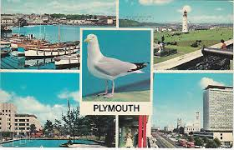 | Create a set of instructions telling me how to get from our school to the Tamar Bridge.
Make a lighthouse out of junk modeling materials.  What special feature will you include? | Physical challenge: How many different balances can you do in one minute? | Create your own beach.

Wk | English | Maths
1 | Make a list of the beaches in Plymouth. | Spend 5 minutes practising the part-part-whole model.
2 | Write an acrostic poem using the letters in Plymouth. | Spend 5 minutes each day counting in 5’s up to 50.
3 | Write a review of a book you have read. Who would you recommend it to? | Spend 5 minutes practising counting in 2’s up to 20.
4 | Create a list of things to do for people visiting Plymouth. | Spend 5 minutes comparing number bonds.
5 | Create an animal character for a story. How can you describe them? | Spend 5 minutes each day practising counting in 10’s up to 120.
6 | Tell me about your favourite place to be. | Spend 5 minutes each day practising 2 more and 2 less than up to 30.
7 | Talk to the people in your family about the animals that you might see in Plymouth? | Spend 5 minutes practising number bonds to 20.
8 | Write a story about somebody in Plymouth. What might they do? | Spend 5 minutes each day practising taking away up to 10.

Try to read every night too!

