Dear Parents

Welcome to the autumn term of Reception and your child’s first school year at St Paul’s! Mrs Byrne, Ms Howe and Ms Yarnold will be your Teaching Assistants and we are very lucky to have them support the learning in Reception. Mr Barrett will also cover my planning time out of class on a Friday afternoon. We are looking forward to seeing you all and working with you this year.

We hope you all had a lovely summer. We are very excited about this upcoming year for your child to reach their full potential in our stimulating environment in our inside and outside classroom. I know that we have recently been through a very unusual and challenging time in education. Many of the children in Reception haven’t been in a nursery since March and I am aware that there will be many anxieties on return to school about how different things may be however, we, the staff, are ready to welcome you and your children back to school with excitement and support. Please feel that you can contact myself via email, clintern@stpaulsplymouth.com , or on ClassDojo if you have any questions and I will be happy to get back to you.

The children will be involved in many different activities throughout the term and we will keep you informed of any relevant diary dates. During the first few weeks of school your child will be taking part in new learning experiences. Expect your child to be tired at the end of the day. Some children may find parting with you in the morning difficult, please try to prepare your child for each day explaining that you will be returning at the end of the day. Some children will settle quickly and some need a little longer but it is all natural. Try not to worry if your child needs longer to settle – we can work together to help them.

Some children may have the occasional wet accident; this is normal and not something to be overly concerned by, we are very discreet and no fuss is made. In Reception class, we have facilities to help clean your child and we will send dirty clothes home in a plastic bag. We can meet and discuss this if the wetting becomes more frequent and is causing your child distress.

- We hope as many of you as possible can help out during the school day, this is of course once we can reassess our current Covid risk assessment. I hope to send out a timetable and if you could help, that would be fantastic. Please also state what you can help with. We always need helpers for reading, gardening, cooking, art and the children enjoy asking about your jobs or hobbies. We also try to incorporate many trips and visits into the school year, and this is only possible due to the support of our parents as we need to have a ratio of 4 (children):1(adult).

Please can you ensure all clothing; bottles, wellington boots and school bags have your child’s name inside. It is also a good idea to help your child to practise opening and closing their lunch box if they will have one – showing them how to unpack their lunch, putting on and zipping up/fastening their coats, trousers and shoes. These little activities will help your child to become more independent and can sometimes help children to feel less anxious.

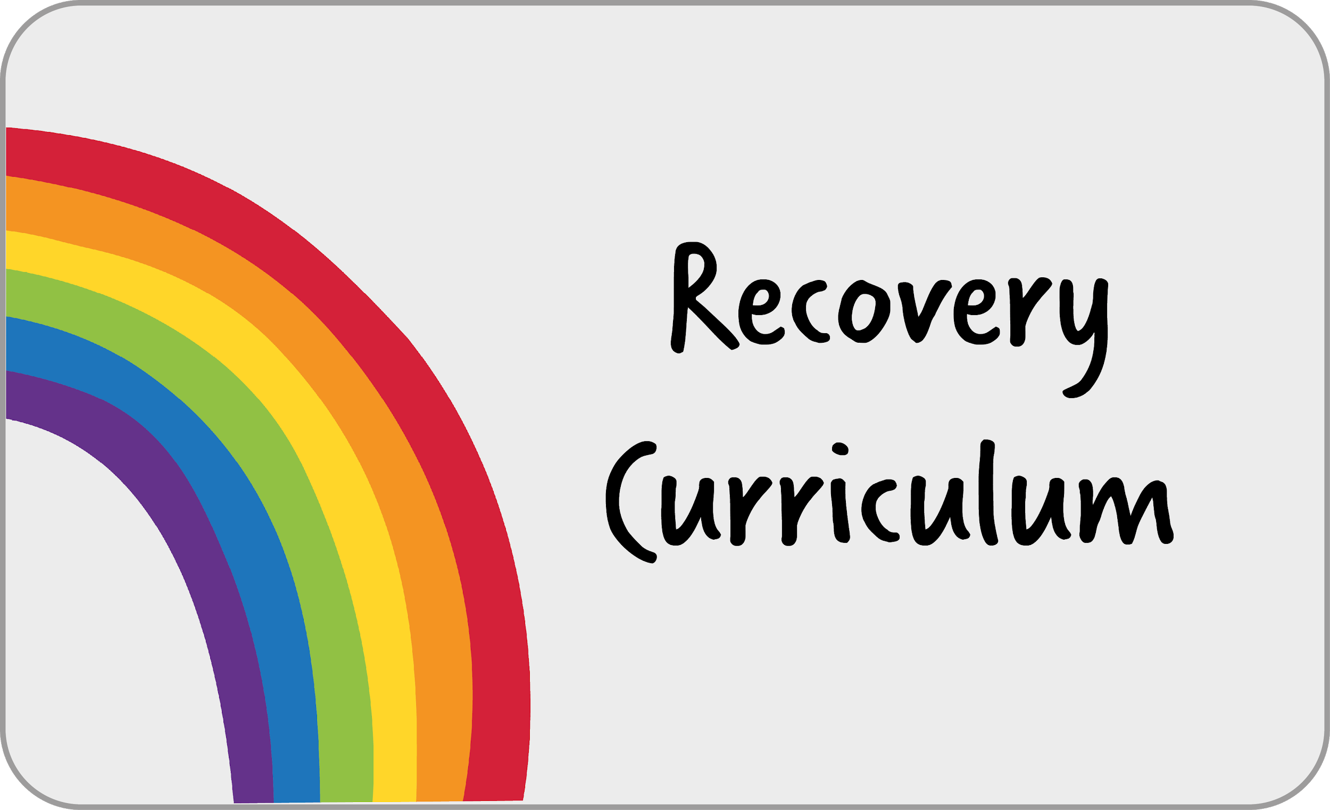
Across the school, we are using ‘Here We Are’ by Oliver Jeffers as our English transition unit. This will provide your child with the opportunity to reconnect with each other and re-engage with school life using their creativity in English and art.
____________________________________________________________________________________________

I’m very excited to share with you that we are beginning a new journey in regards to the teaching of the curriculum.
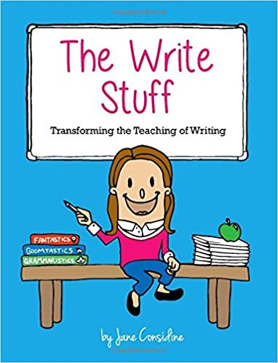
We are going to be following ‘The Write Stuff’ for our English learning. Jane Considine has developed an approach that enables children to develop as confident writers through teacher modelling. I’m really looking forward to using this new approach to support your child in becoming accomplished writers.
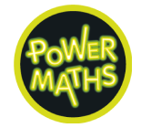

We are also going to be following ‘Power Maths’ for our maths learning. This is a mastery programme designed to spark curiosity and excitement and nurture confidence in maths. This is a fantastic curriculum that I am sure the children will enjoy using to develop their maths knowledge, understanding and skills.

We are also going to be following ‘Come and See’ for our RE learning. This is a programme designed to allow children to search for meaning in life through a Christian perspective. It provides children with the opportunity to explore, reveal and respond throughout the learning process.

As part of the Plymouth Catholic School Cluster (the six Catholic schools in Plymouth), we have worked together to create a progressive curriculum for the foundation subjects that seeks to provide pupils with the essential knowledge they need to be educated citizens in tomorrow’s world.

Autumn Term 1 Theme- All About Me

Religious Education  Family  Our first RE unit is about the Domestic Church (family) and how love is shown in a community linking to the fact that God shows unconditional love.  Our second unit is about Holy Orders and an individual’s mission and commitment in life.  Skills we will learn:  To show sensitivity to others’ needs and form positive relationships with adults and other children. | English  Reading and making predictions  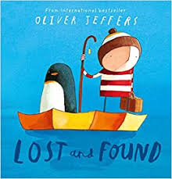  Our writing will be based on the book ‘Lost and Found’ which links to our recovery curriculum book ‘Here we are’ also written by Oliver Jeffers.  Skills we will learn:  To listen and join in with stories and anticipate key events and phrases.  To be aware of the way stories are structured and how the story might end.  To take an active part in phonics games, use pictures as cues but encourage the use of sounding out initial sounds. | Maths  Recognising  Skills we will learn:  Unit 1: Numbers to 5  To count reliably to 5 and place them in order, knowing how to count forwards and backwards.  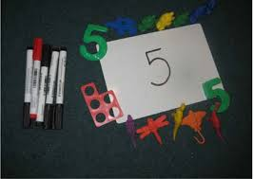  Unit 2: Sorting  To compare and discuss characteristics of everyday objects.
Art  Self portraits  Skills we will learn:  Sometimes give meaning to marks as they draw and paint.  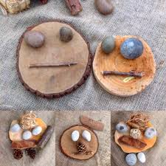 |  | Computing  Skills we will learn:  To select and use a range of audio and visual recording equipment to interact and explore the Reception environment.
Music  Nursery Rhymes  Skills we will learn:  Recite songs and make music and dance to experiment with ways of changing known songs. | PSHE  All about me  Skills we will learn:  To recognise familiar words and signs such as their own name, photo and toys.  To be able to share with the class what they like and dislike.  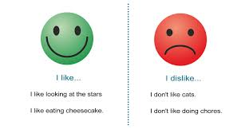 | Physical Education  Skills we will learn:  To manage their own basic hygiene and personal needs successfully, including dressing and going to the toilet independently.  On Fridays, the children will have a structured lesson focussing on balance and hand eye coordination.

Autumn Term 2 Theme- Rhythm and Rhyme

Religious Education  Our first two RE units are focused on the faiths Islam and Sikhism.  Our second unit is Advent where we prepare to receive Jesus into our lives and to share this gift with others at Christmas and throughout the year.  Skills we will learn:  To know there are similarities and differences between themselves with other people, families, communities and traditions. | English  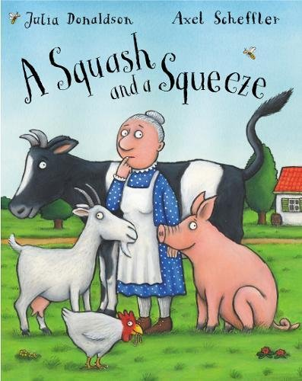  Our unit of work will be focused on nursery rhymes and the rhyming books by Julia Donaldson, ‘A Squash and a Squeeze’.  Skills we will learn:  Through rhyming and rhythmic activities we will show awareness of rhyme, alliteration and recognise rhythm in spoken words.  To confidently handle books and talk with others about what they have read. | Maths  Skills we will learn:  Unit 3: Comparing groups within 5  To say which number is one more or one less than a given number.  Unit 4: Change within 5  The foundation skills for addition and subtraction although, at this stage, children should not be expected to use the addition or subtraction signs.  Unit 5: Time  To develop a sense of time in terms of daily routine that will give them the foundation skills they will need for further work on time in Year 1.
Science  Skills we will learn:  To make observations of nature and explain why some changes occur and talk about seasonal changes. |  | Computing  Skills we will learn:  To sequence and order instructions to enable them to use simple apps and coding games.  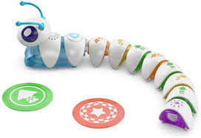
Phonics:  Skills we will learn:  To segment what we read using our Fred Talk and other Read Write Inc strategies.  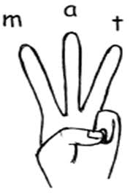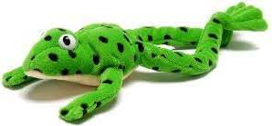 | PSHE  Skills we will learn:  To talk about how they and others show feelings, talk about their own behaviour and its consequences.  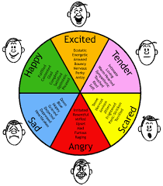 | Physical Education  Skills we will learn:  I can hold a pencil and other mark making tools correctly. I can confidently use other tools and equipment appropriately.  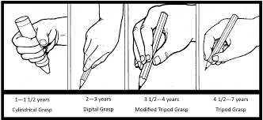  On Fridays the children will have a structured lesson focussing on following simple rules .

HOME READING We will be changing books each Monday and Thursday, when your child will be given two books. Your child will be expected to reread these books. Rereading books is good practice as it moves children from reading for decoding, through reading with expression and finally onto reading for meaning. Please listen to your child read and, more importantly, talk about what is being read as often as you can. Then finally log it in your child’s reading record. Please read the guidance on our Read Write inc phonics scheme that is stuck in the middle of your child’s reading record. Also in the middle, are stickers that your child works towards achieving. Please note that they are for teaching staff to award so please refrain from letting your child peeling them off. As I'm sure it will be tempting!
HOME LEARNING Home learning always relates to learning in class. It is set once a month in Reception and you will find out about each project nearer the time on paper and on class dojo. The children will be expected to practise number facts using online programs such as Numbots, Rapid Recall and IXL. However log in details and further information will be given out to you at a later date. If you require further activity packs for school holidays or over the weekends then please just let me know.
School uniform: I am sure the children will arrive at school looking smart and ready to learn. It is not necessary to wash uniforms every day but we do advise that children change out of their uniform immediately after arriving home and wash their hands with hot water and soap.
Jewellery/makeup:

- For safety reasons, children should not wear jewellery to school. Children with pierced ears may wear discreet studs, although these must be removed for PE.
- No nail varnish/makeup

PE: Reception children should wear PE kits to school on a Friday to remove the need to change. On colder days, it is acceptable for children to wear navy leggings or joggers instead of shorts. Trainers or plimsolls may be worn. This will commence from the week commencing 14th September 2020 as all children will be in school full time.

Key dates:
Thursday 3rd September or Friday 4th September Stay and play sessions.
Monday 7th September -Friday 11th September 9.05 am - 12.30pm Children will have eaten their lunch.
Monday 14th September onwards 9.05am- 3.00 pm if no siblings in school.

Snacks and packed lunches: We are committed to being a healthy school. All Reception and KS1 children are provided with fresh fruit on a daily basis and do not require any additional snacks.

All children require water bottles for use in class. These must have a sports cap so that school books are not at risk of being damaged. Only water is allowed to be consumed in class time. School water bottles are available for purchase from the school office and must be named.

Please ensure that your child brings a waterproof coat with them each day. You may also bring a spare pair of wellington boots so that your child can continue to explore outside in all weather conditions comfortably.

I am sure we will have a great term; and I look forward to working in partnership with you and your child. Please don’t forget to post any wow moments on class dojo portfolio to share the amazing learning experiences happening outside of school.

Miss Lintern
Reception Class teacher

