Year 4 Curriculum Newsletter - Autumn 2020
4th September 2020
Dear Parents and carers,
It was a pleasure to welcome your children into Year Four this week. They have started the term full of enthusiasm. I am delighted to be continuing this next step in their school journey with them.
EARLY MORNING TASKS The new morning routine allows the children to come into the classroom from 8.45 onwards. Upon arrival they settle quickly to learning tasks such as number operation practice and word games. Children must arrive by 8.55 to start the school day on time. Thank you for your support with this so far.
HOME READING We will be changing books each Monday and Thursday, when your child will be given 2 books. Your child will be expected to reread these books. Rereading books is good practice as it moves children from reading for decoding, through reading with expression and finally onto reading for meaning. Please listen to your child read and, more importantly, talk about what is being read as often as you can. Sharing a story together is a great way to spend time with your child.
HOME LEARNING Homework always relates to learning in class. The children will be asked either to practise applying knowledge and skills already introduced in class or to complete a research project linked to the term’s theme. The children will also be expected to practise number facts (e.g. times tables) and spellings as set. Homework is set every Friday and is due in the following Wednesday. Spellings are set every Monday and tested every Friday.
School uniform: The children have arrived back at school after the Summer holiday looking smart and ready to learn. Please refer to the following details from our prospectus if you are unsure:
Uniform:
- Grey trousers/shorts
- Navy blue skirt or pinafore
- Navy blue sweatshirts or cardigans
- White polo shirts in foundation/KS1
- White or navy blue tights or socks
- Black shoes

Jewellery/makeup:
- For safety reasons, children should not wear jewellery to school. Children with pierced ears may wear discreet studs, although these must be removed for PE and swimming.
- No nail varnish/makeup
PE:
- All pupils should have a PE bag to hold their sports kit, comprising of their house colour t-shirt, navy blue shorts and plimsolls or trainers.
- Trainers may be needed for outside PE throughout the year.
- During the winter children may have tracksuit bottoms in their bag and a jumper with long sleeves.
Please ensure that all kit and uniform is clearly named so that your child can easily locate lost items of clothing.

Snacks and packed lunches We are committed to being a healthy school. All Foundation stage and KS1 children are provided with fresh fruit on a daily basis and do not require any additional snacks. All children require water bottles for use in class. These must have a sports cap so that school books are not at risk of being damaged. Only water is allowed to be consumed in class time.

Please ensure that your child brings a coat with them each day or some suitable form of outerwear.
Please do not hesitate to contact me with any queries or concerns. I am always happy to speak to you when you pick your child up at the end of the day or contact me via email on sbarnes@stpaulsplymouth.com . If you require more time, I am more than happy to make an appointment with you.
Kind regards, Mrs Barnes
Our first theme will be ‘Incredible Me!’ We will be exploring personal qualities of ourselves and others and thinking about real life superheroes.
Religious Education  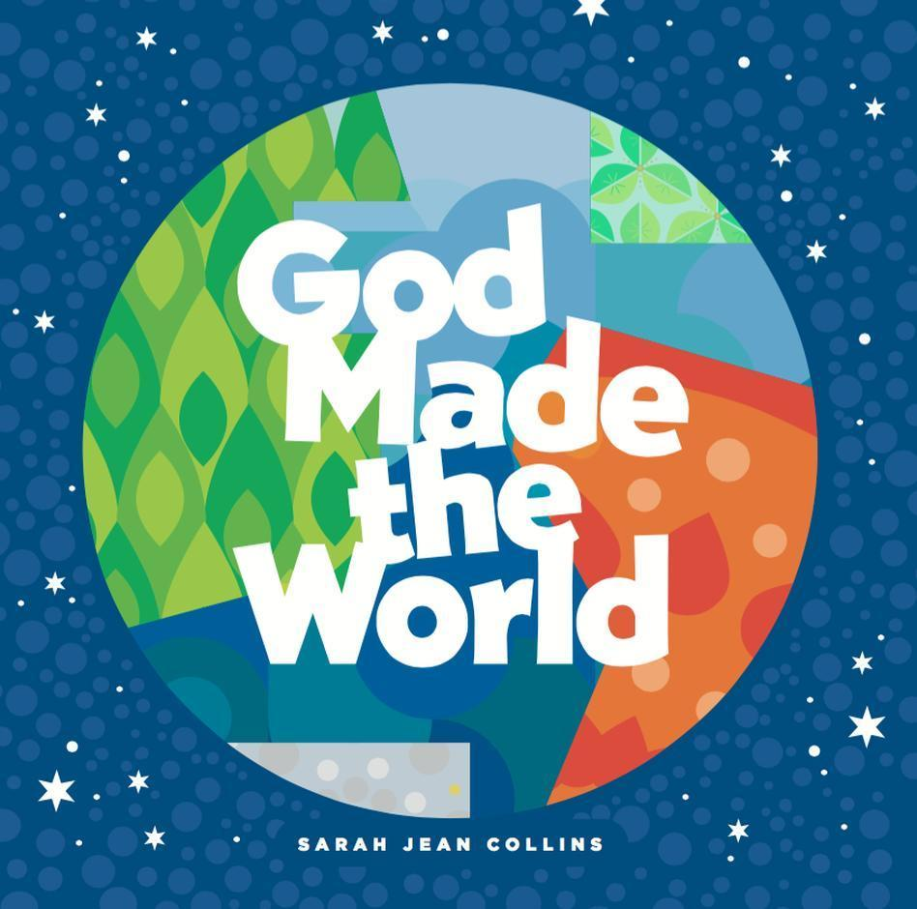  Our first RE unit, Creation,  focuses on God as a creator and our responsibility to protect his creation.  Our second RE unit, Prayer, Saints and Feasts, focuses on people who care for us and help us to know  God. | English  We will use the text ‘Traction man’ to support of story writing and then move onto writing a set of instructions ’How to make a superhero.’ | Maths  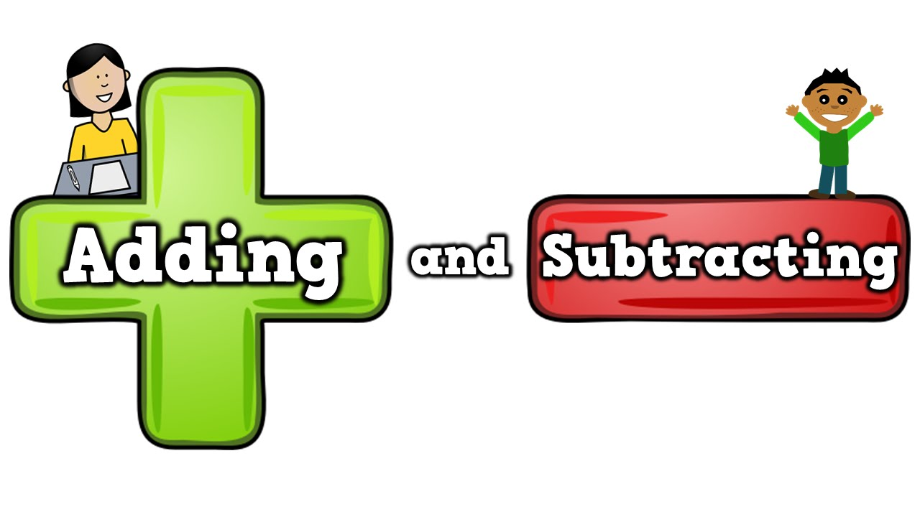  This term our maths will focus on developing our understanding of place value. We will then continue to develop or addition and subtraction skills.
Art and Design Technology  We will be exploring our artistic talents by designing a new costume for our own superhero. | Science  In Science, we will be exploring the properties of materials and considering their uses. | History  This term we will look at some real life superheroes of the past and consider the impact they have had on our lives.
Computing  We will be learning how to log on and sue a variety of programmes. As in previous years,  we will cover online safety. | PSHE  We will spend a considerable amount of time exploring our feelings, good and bad. We will begin to think about how we can control them and the effect they have on those around us. | 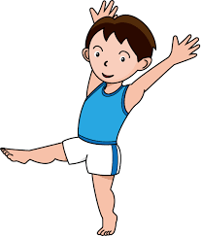  Physical Education  We will have PE on a Tuesday  and Wednesday afternoon.  Please ensure that PE kits are always in school.

Our second theme ‘Plymouth on a postcard’ gives us the opportunity to explore the wonderful city we live in.
Religious Education  Our first RE unit teaches us about Sacraments.  Our second RE unit, Advent, helps us to prepare for the birth of Jesus.  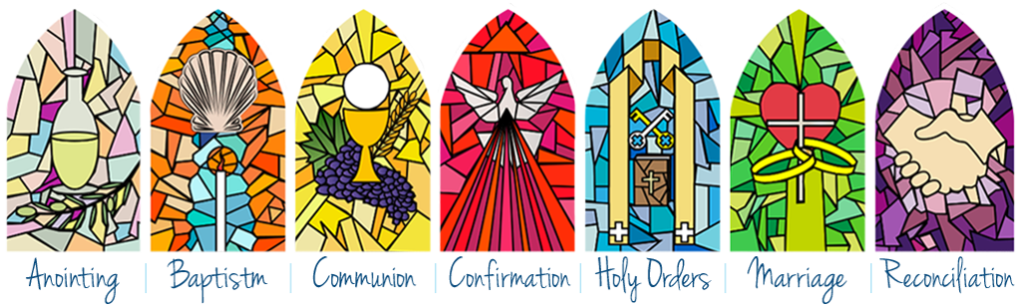 | English  In our English sessions we will be looking at a range of stories by local author, Simon James. We shall compare the texts and then use them as a stimulus for our own writing. | Maths  We will begin to develop our knowledge of multiplication and division. Then we shall increase our understanding of fractions.  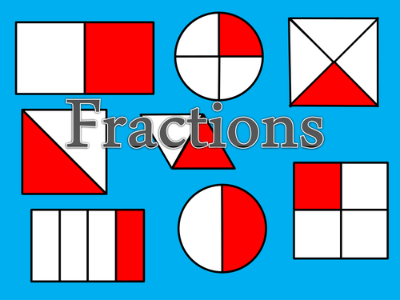
Geography  During this topic we will learn more about the UK; the countries it includes and their capital cities. | 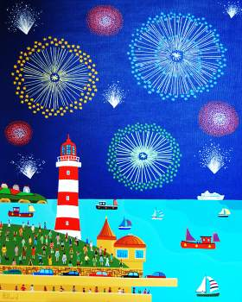  Art and Design Technology  We will study the work of local artist Brian Pollard and then create our own Plymouth art. | History  Our studies this term will focus on Guy Fawkes and his legacy.  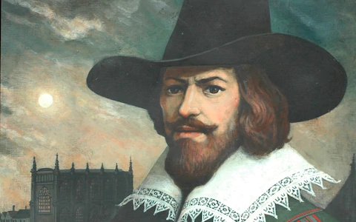
Computing  This term we will learn how to use spreadsheets to collate data. | PSHE  This term we will continue to look at friendships and how we can develop positive relationships. | Music  We will compose music inspired by our amazing city and its features.

