Friday 18th January 2019

Dear Parents/Carers

It has been a busy start to the new term, with the children enjoying many exciting learning opportunities. We are delighted that the children have started the spring term with such a positive attitude to their learning. This week, we hear from the Foundation class and Year 4.

Learning at St Paul’s
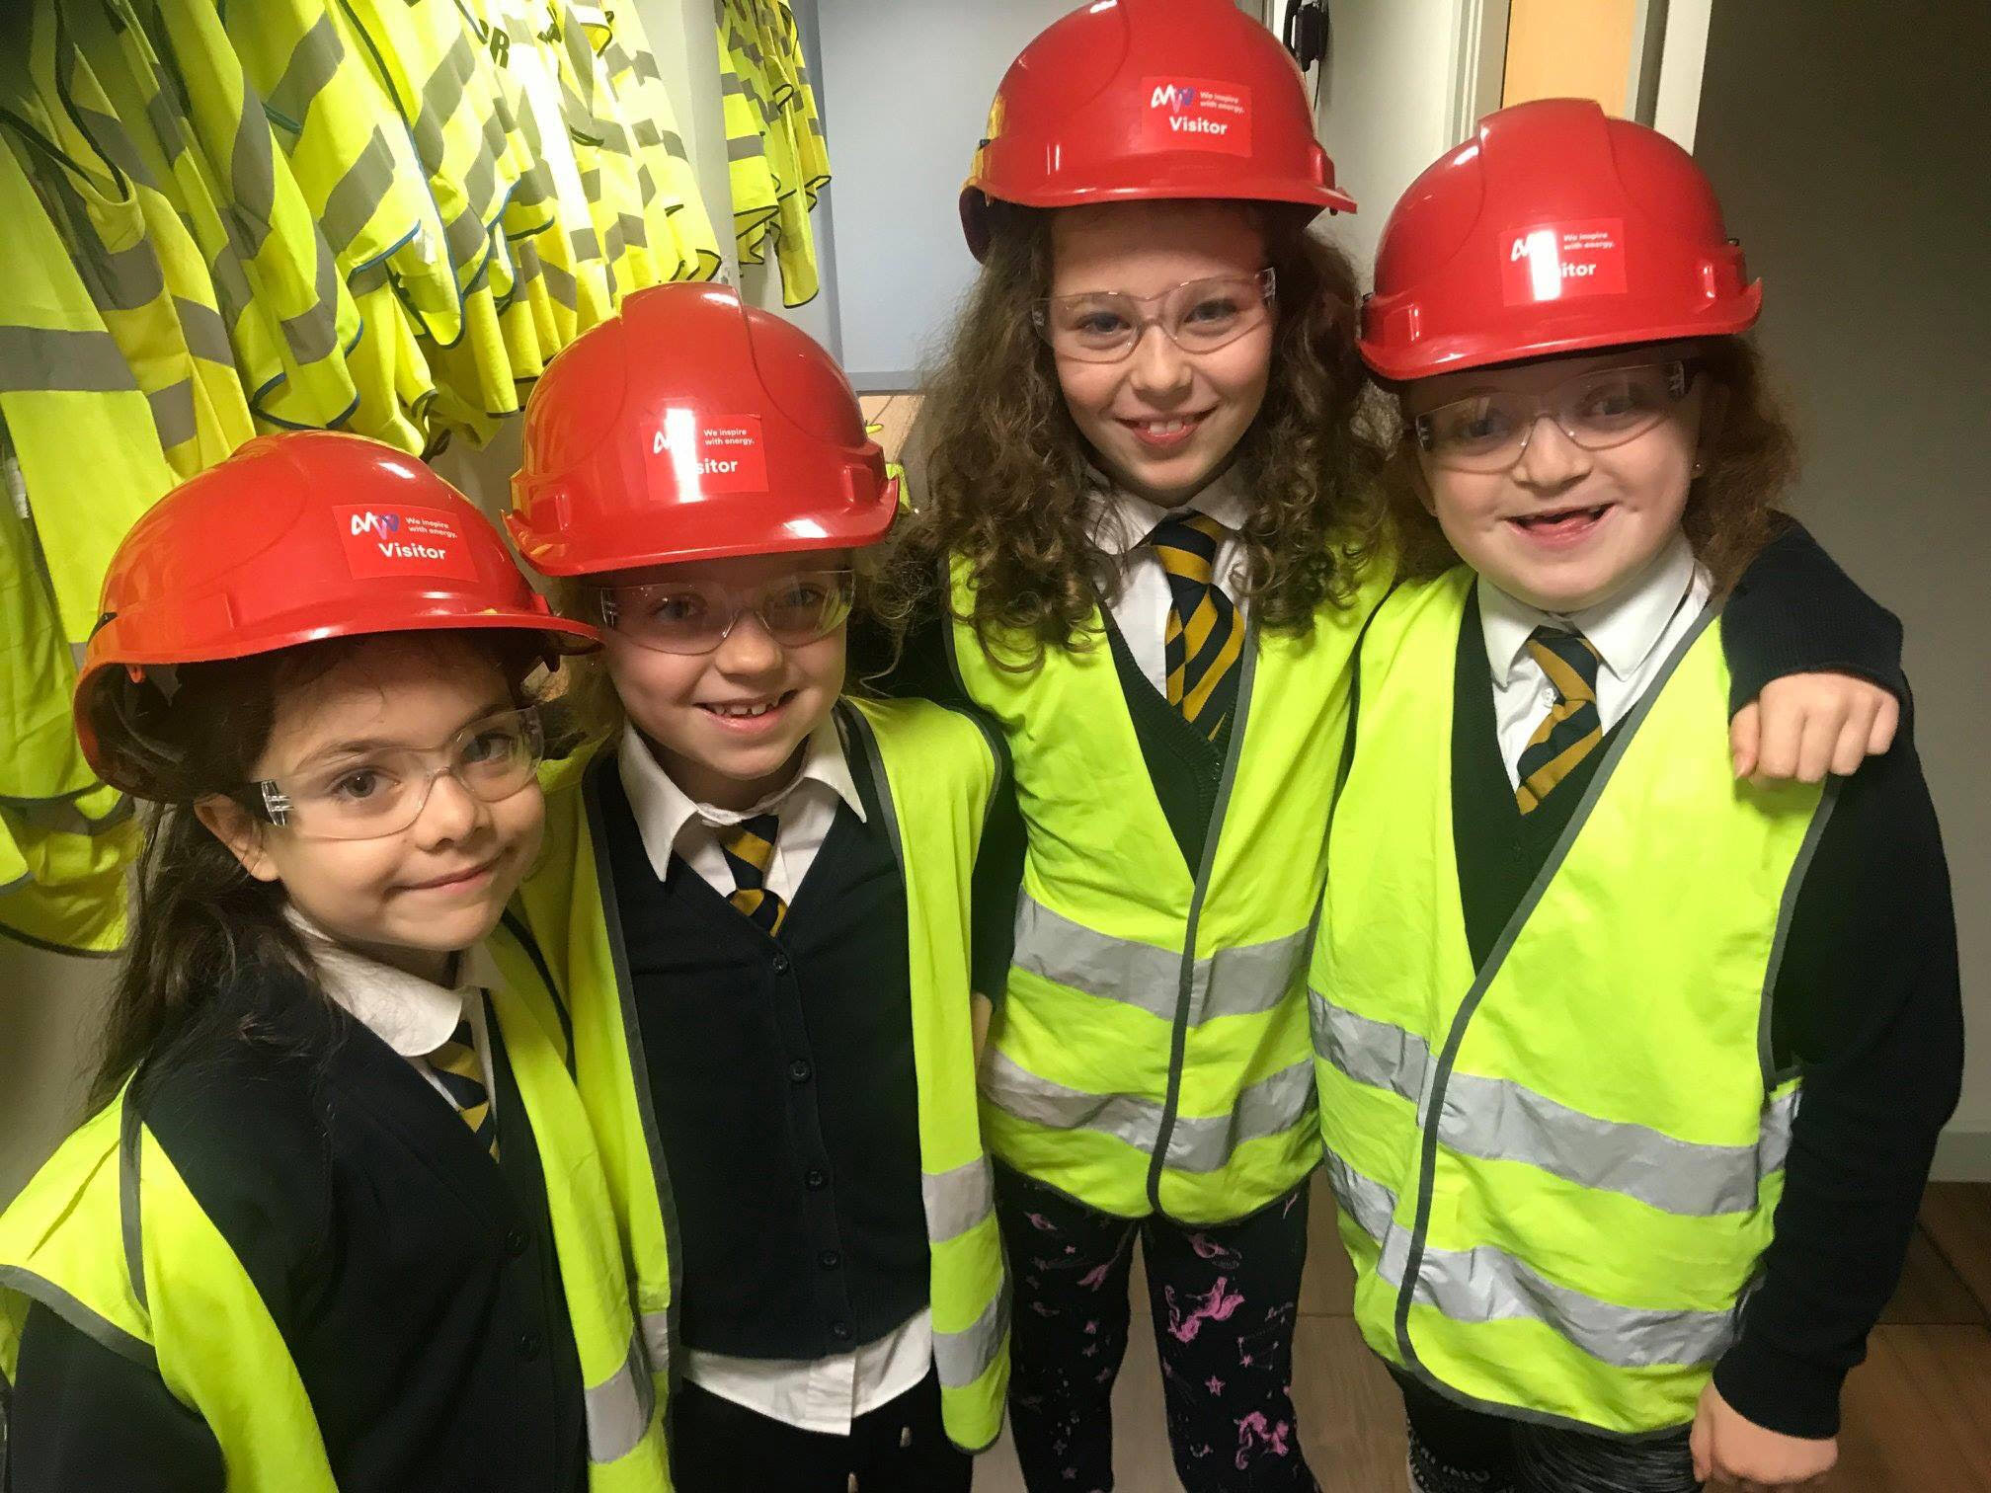
Wow! What an amazing day that was! On our trip to the incinerator we did some really interesting activities. One of our activities was a site tour. First. We went to the loading area and saw the rubbish trucks dropping off the rubbish. Then we went up to the control room and learnt what couldn’t be burnt in the furnace. It’s fantastic what you can do with rubbish. We saw the claw as well and some children even got to control it! After that, we saw the furnace blazing at 1000 degree Celsius. Now that’s hot! It was so hot we had to look at the fire through a window. After all that, we did a quiz about the incinerator tour. We answered all the questions correctly. Finally, we were making fabulous bridges out of newspaper and tape. My favourite part of the trip was when we saw the furnace through the window.
Jack and George Year 4
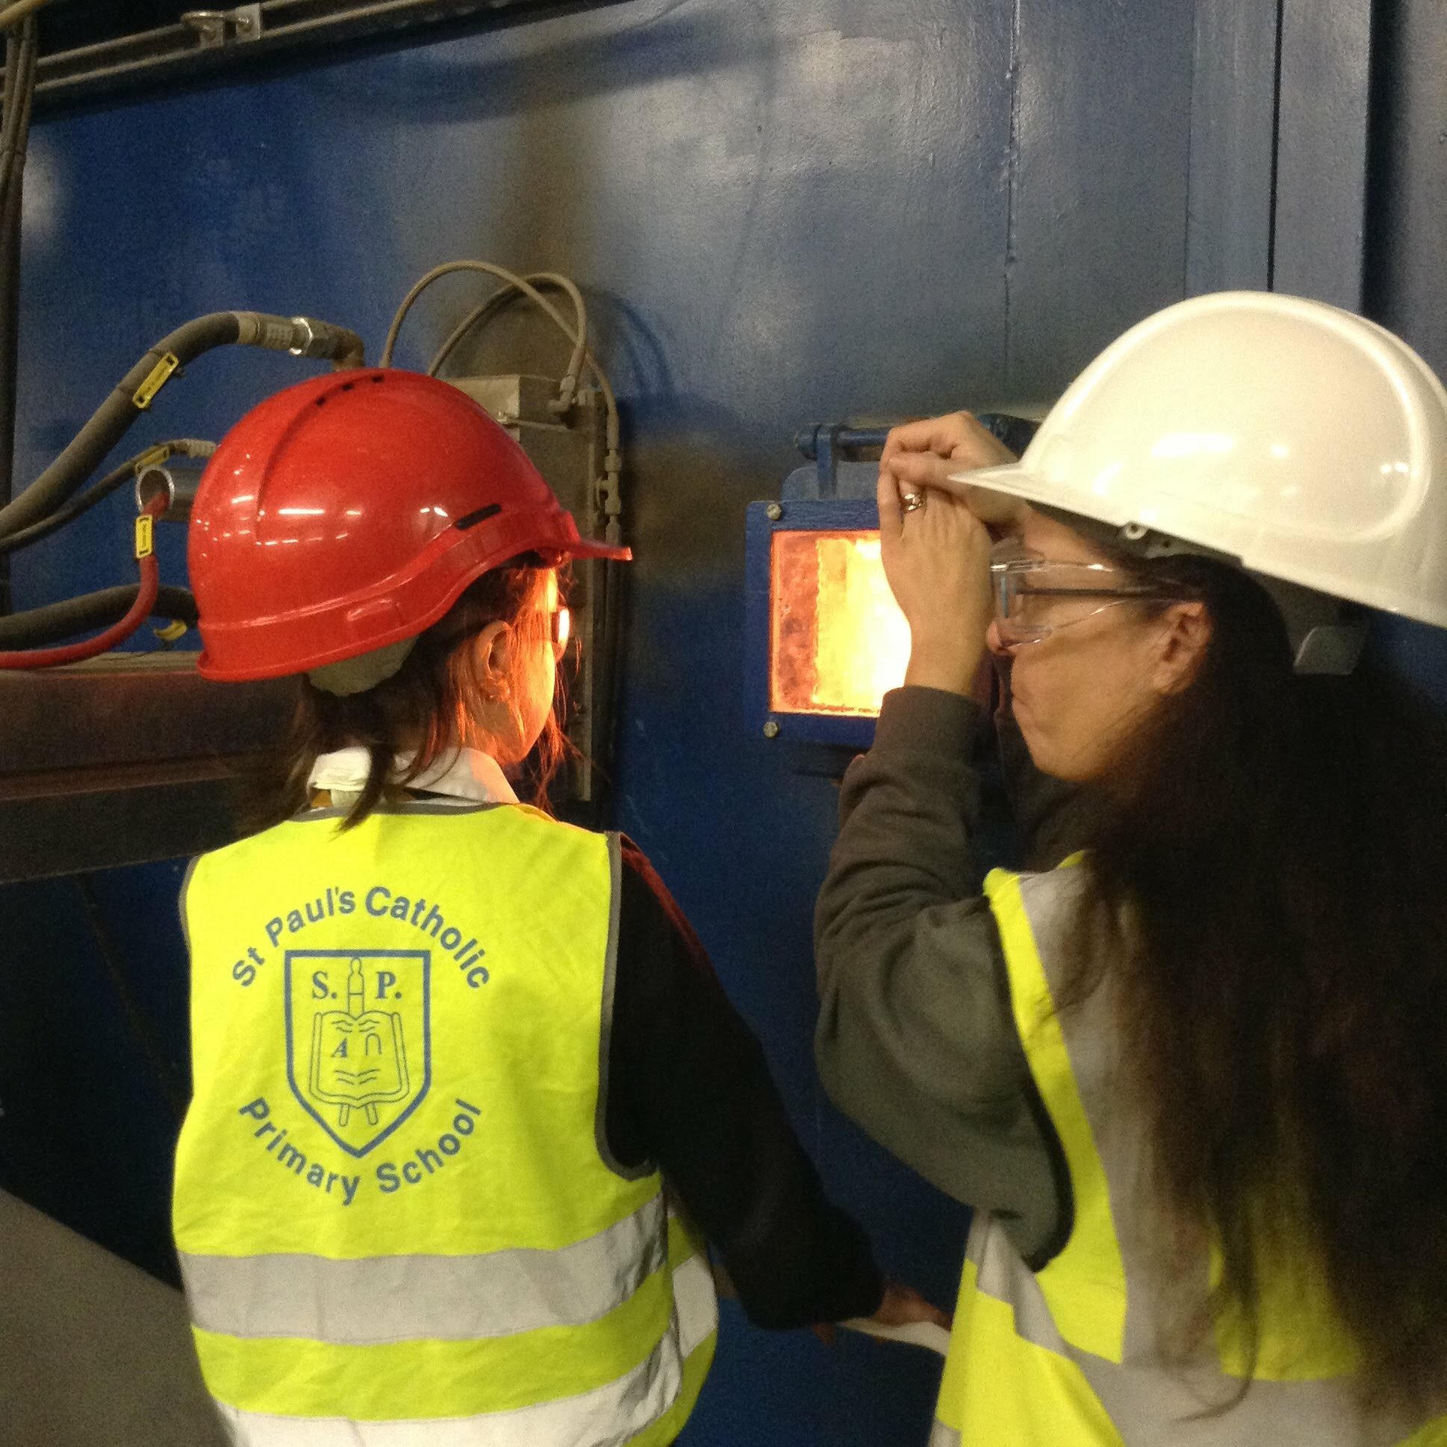
Wow! What an amazing day that was! On our trip to the incinerator we did some really interesting activities. One of our activities was a site tour. First. We went to the loading area and saw the rubbish trucks dropping off the rubbish. Then we went up to the control room and learnt what couldn’t be burnt in the furnace. It’s fantastic what you can do with rubbish. We saw the claw as well and some children even got to control it! After that, we saw the furnace blazing at 1000 degree Celsius. Now that’s hot! It was so hot we had to look at the fire through a window. After all that, we did a quiz about the incinerator tour. We answered all the questions correctly. Finally, we were making fabulous bridges out of newspaper and tape. My favourite part of the trip was when we saw the furnace through the window.

In Foundation we have been very busy getting stuck into our new topic People who help us. Last week we focused on firefighters and the important job they do in keeping us safe. We designed our own fire engines, wrote a descriptive caption about a fire and enjoyed role playing in our dolls house. This week we have been focusing on farmers and learning where our food comes from. The children have enjoyed taking part in a healthy and unhealthy food sort activity, decorating tractors, looking after animals in the hospital role play and learning all about our class story of the week Farmer Duck.

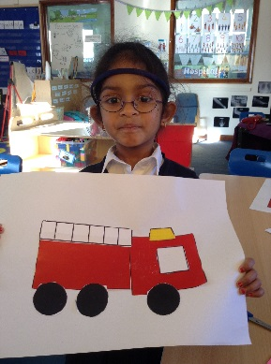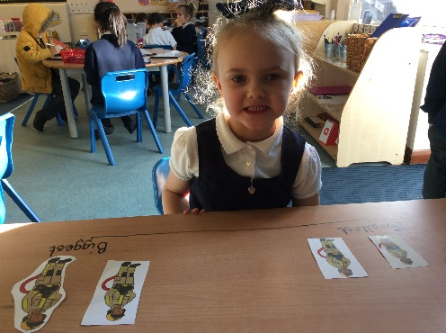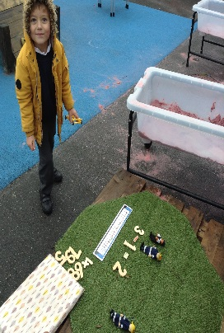

You will have the opportunity to discuss your child’s learning with class teachers later this term. We have parent consultation evenings arranged for week commencing 25th February and details of how to book will be sent home soon.

High expectations
We are very proud of our school and the high expectations we have. Please refer to our uniform policy to ensure your child arrives at school smartly dressed. The children have many opportunities to represent our school in the parish and the local community and it is essential that they are showing our school at its best. In particular, children should wear black school shoes - no trainers. We also ask that hair accessories are discreet - please keep large bows and headbands for the weekends.

Attendance
Excellent attendance is also important to your child’s education. We ask that medical and dental appointments are arranged before or after the school day, wherever possible. We are aware that some appointments have to be during the school day but we still expect children to attend school before and after the appointment, unless it is very early in the day. Please be aware that if it is necessary for a child to be released during the school day, we cannot release siblings at the same time. Please ensure the school office are kept informed about any last minute changes to pick-up arrangements for your child because we cannot release children to anyone other than parents/carers unless you have notified us otherwise.
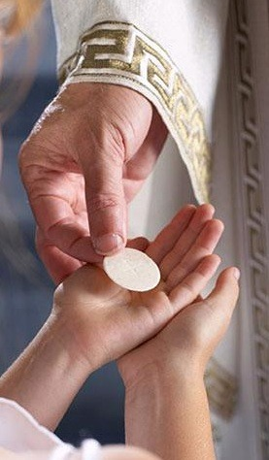
First Holy Communion
Children in year 3 and above are eligible to prepare to receive the sacrament of Holy Communion this year. Preparation for First Holy Communion will be starting in the near future and will take place in St Paul’s parish room. Please contact the school office or Fr Petroc directly if you would like your child to prepare to receive this sacrament. Miss Hill and I are happy to answer any queries you might have.

Beginning and end of school days
It is wonderful to greet so many of you as you arrive with your children in the morning. Thank you to those of you who arrive on time and park away from site. All children must arrive between 8.45 and 8.55 each morning. Unfortunately, a small number of our parents are still parking unsafely on the lane and putting our children at risk. We will be addressing this directly with any parents who continue to behave in an inconsiderate way.
We also ask that you arrive promptly to collect your child at 3.15pm. Our teaching staff cannot be expected to wait every afternoon for late arrivals. Thank you to the many parents and carers who behave considerately every day - we appreciate your support.

Advance notice
World Book Day will take place on Thursday 7th March. Watch out for more details from Mrs Griffiths! Children will be invited to dress as their favourite book character so get your costumes ready!

Sports Day will take place on Wednesday 12th June with a reserve date of Wednesday 19th June. More details to follow.

Mass Dates
Thursday 24th January – KS1 Liturgy – 2nd Sunday of Ordinary Time
Thursday 31st January – Y5 & Y6 – 3rd Sunday of Ordinary Time
Thursday 7th February – Y3 & Y4 – 4th Sunday of Ordinary Time
Thursday 14th February – KS1 – Liturgy - 5th Sunday of Ordinary Time

With very best wishes
Mrs Dawn Potterton
Head Teacher

