St Paul’s Catholic

Primary School

Maria Anderson

Headteacher

St Paul’s Catholic Primary School
Pemros Road

St Budeaux
Plymouth
PL5 1NE
Tel / Fax: 01752 365459

Email: admin@stpaulsplymouth.com
Website: www.stpaulsplymouth.com
30th October 2018

Dear Parents and Guardians,

Myself and Barbara are writing to let you know formally that our long standing governor Fred Pearce has retired as a governor at the school. As you will all know Fred has been a governor at the school for 38 years and during that time given 100% commitment throughout. He has supported the school tirelessly, always striving for the best for the children, staff and families.

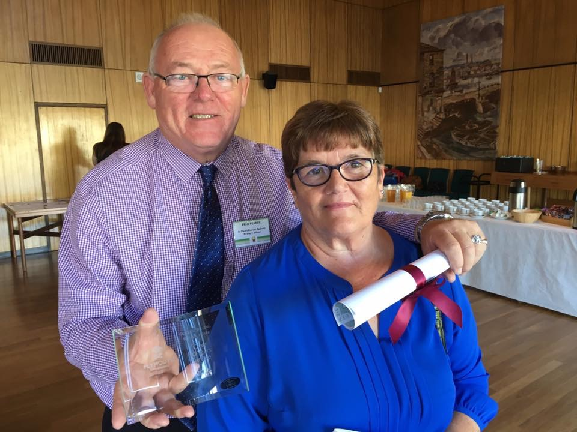
During those years, he has taken a lead on Health and Safety and Building and Maintenance in the school. You will all see that the school is well looked after and key maintenance is kept on top of due to his drive in ensuring our children have a good environment to learn in both inside and outside the classroom. We have been very fortunate to have someone with that level of knowledge about these areas, challenging us on our Fire Evacuation timings or the quality of our singing!

Fred has been so reliable and unflappable in a crisis and in support with the day to day running of the school- whether a leaking tap, a flooding toilet, or making the staff laugh in the staff room. His sense of humour, warm friendly personality, commitment, perseverance, passion, energy, enthusiasm has kept the team at St Paul’s on their toes. His warmth, encouragement, patience, support, listening ear and green fingers has developed the love of the young people at the school. There is always a buzz of excitement when Fred is around!
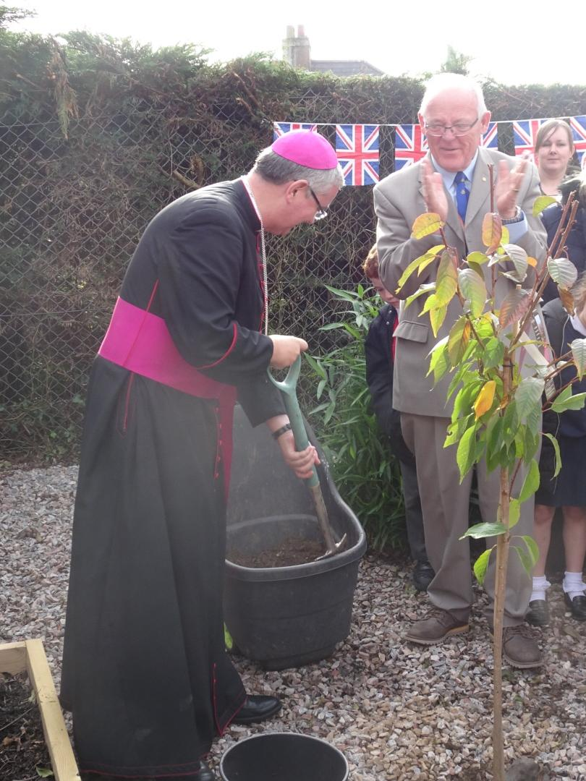

On behalf of the children, staff, governors, families and Parishioners we would like to say a massive thank you to Fred for everything that he has given St Paul’s and wish him every happiness in the next phase of his life.

Best wishes

Maria Anderson and Barbara Kirk

