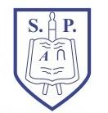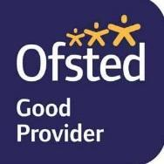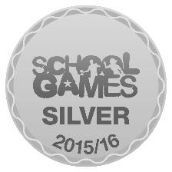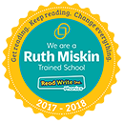

Newsletter: Friday 5th October 2018

Message from Mrs Anderson…
It was lovely to see so many of you in school this week for parent consultations. It is so important that you all come in and discuss how your child has settled into their new year group, together with how they are doing with their learning. If you did not make a meeting this week, please can you make sure you make a suitable time over the next two weeks. The team will be calling families who did not make the meetings.

Parent Governor vacancy…
We are delighted to announce our new parent governor, Mrs Sharron Bates. Thank you to those of you who returned the ballot papers. Your parent governors at the moment are Mr Cheetham, parent of a child in year 2 and 4, and Mrs Bates, parent of a child in foundation.

Parent Advisory Group…
Please help, we need you to be part of our ‘Parent Advisory Group.’ As I said in the last newsletter we meet termly for approximately 1 hour and discuss relevant items to do with the experiences of your children at school. We aim to have one representative per class. If you are interested please send me an email, manderson@stpaulsplymouth.com.

Photographer…
The photographer will be in school on Wednesday 10th October to do individual & sibling photos- next week!

Gospel message…
This weekend the Gospel describes Christ's love for children and while displaying this love he stresses the need for all his true followers to be childlike. "I say to you, whoever does not receive the kingdom of God like a child shall not enter it." To receive the kingdom of God is to accept the teaching of Christ and live according to it in his kingdom on earth. He who does this will enter, after death, into the eternal kingdom of heaven. Christ says, however, that we must accept "like a child": his kingdom on earth, his teaching and the Church he founded to carry on that teaching. We must remember to follow Christ’s way and accept the challenges he gives to us.

Masses: 11th October – St Luke– Fu & KS1
18th October – Our Lady – Y5 & 6

Attendance: 100% attendance– will it be you?” The winning class this week is Y1 with 99.24%.

The whole school attendance for the week is 95.15% we really need to aim to get 97%!

Star Learners for last week were: Reggie B & Tabitha Fu, Abbas & Reno - Y1, Lillie-May & Filip - Y2, Sebastian & Jessica - Y3, Donavan & Eli - Y4, Liam & Zac - Y5 & Alfie & Summer - Y6

Star Writers this week are: Jojo Fu, Jackson Y1, Shilah Y2, Eliza Y3, Joshua Y4, Daniel Y5 & Seren Y6

Star Readers this week are: Emily Fu, Lily Y1, Edison Y2, Ross Y3, George S Y4, Emily Y5, Tom Y6

Best wishes
Maria Anderson

